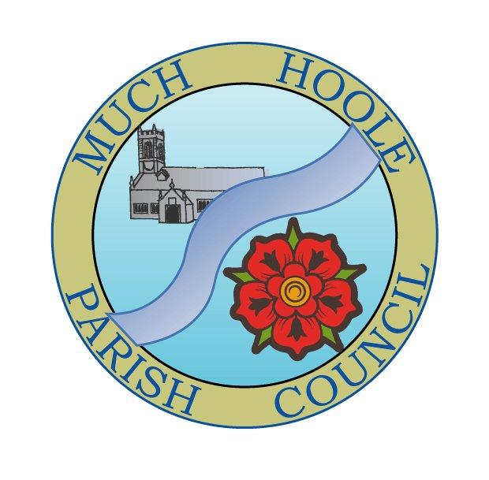 | MUCH HOOLE PARISH COUNCIL  NOTICE OF MEETING
You are summoned to attend a Meeting of Much Hoole Parish Council to be held on Monday 11th April 2022 at 7.30pm. at The Venue (Hoole Village Memorial Hall) Liverpool Old Road. Members of the Public are invited to attend.

Russ Weaver, Clerk to the Parish Council

AGENDA
1. | Apologies for Absence  To receive apologies for absence:  Cllr Woodcock (work commitment)
2. | Declaration of Interests and Dispensations  - To receive declarations of interest from Councillors on items on the agenda  - To receive written requests for dispensations for disclosable pecuniary interests (if any)  - To grant any requests for dispensation as appropriate
3. | Minutes of last meeting  To resolve to agree the minutes of 14th March 2022 as a correct record
4. | Public Time  To invite and listen to issues raised by members of the public.
5. | Cycle Track  An update will be presented on the progress of the maintenance work previously authorised  The next lease payment is due on 11th April 2022 (see item 6g below)
6. | Finance  To authorise payment of the following:  - To pay Clerk in sum of £240 net pay (for March)  - To pay the Clerk mileage expenses in the sum of £7.20  - To pay HMRC in sum of £60 PAYE (for March)  - To approve payment of £398.86 to LALC for annual subscription  - To approve £231 planning application fee (cheque)  - To approve payment of annual grant to support upkeep of St Michael’s Church Burial ground  - To approve to pay Alan Taylor cycle track rent of £90 as per lease.  - To approve payment of up to £100 to replace the damaged flagpole Numerous 6m flagpoles are available with next day delivery for under £100.  - To note end of year bank balances and bank reconciliation  - To note remittance from SRBC in sum of £8,156.11 for CIL  - To note that the Clerk opted to remain outside of the Local Govt Pension scheme and the Council has fulfilled its legal obligations with the Pension Regulator.
7. | Reports from / notice of other meetings attended by Councillors or Clerk  To receive reports from meetings attended by Councillors, or notification of meetings due to be attended  Cllrs Lea and Woodcock attended an LCC ‘Highways Special’ on Saturday 19th March  Cllr Hayes attended the parish Chairs meeting on 21st March  Cllr Houghton attended the LALC executive committee meeting on 24th March 2022
8. | Community led projects  - Progress reports and proposals in relation to ongoing community projects  - To consider spring planting and any additional planting areas/planters  - To receive an update from the management of the Village Hall.
9. | Footpath repairs  A recent survey of footpaths has identified a number of paths in need of repair to stiles and bridges. These have been reported to LLCC PROW team but remain ‘pending’ after several months. Cllr Cocker will update the Council on potential repairs under the delegated scheme and budget provided by LCC
10. | Queens Jubilee  To discuss any issues in relation to the Jubilee celebrations.
11. | Variation in Speed limits  To consider the proposals for a 50mph speed limit on the A59 through Much Hoole and response to the consultation
12. | Training  To consider any requests for training
13. | Planning  Hoole 07/2022/00114/FUL  Hannings Farm, Haunders Lane, Much Hoole, Preston, Lancashire, PR4 5JR  Erection of two storey dwellinghouse in new location replacing the existing dwelling, barn and outbuilding. Mr William Bracewell Delegated Decision. Mrs Linda Ashcroft Tel: 01772 625409
14. | Items for the Next Agenda (for information only)  Annual Parish Council Meeting, Election of Chair and Vice Chair, Internal audit report and annual returns if complete. Renewal of General power of competence.
15. | Date of Next Meeting  The Parish Council to agree the date of the next meeting as 7.30pm 9th May 2022 at the Venue

